# MAT 303 Module Three Problem Set Report

Second Order Models

[Luna Saccoia]

[Luna.Saccoia@snhu.edu]

Southern New Hampshire University

## **1. Introduction**

*The data set I will be exploring is on the economy and the variables that can have an effect on it. These results might be used by economists to study and predict how different scenarios can affect the economy. They can run models with different scenarios to see how changes in certain variables would affect other variables.*

*The analyses I will be running in this problem set include three quadratic (second order) multiple regression models; One with a quantitative variable, one with two quantitative variables and one with a quantitative and qualitative (categorical) variable.*

## **2. Data Preparation**

*The important variables that I will be analyzing in this problem set, for each model are below:*

* *Model 1: wage growth as response variable and inflation as predictor variable.*
* *Model 2: wage growth as response variable, and inflation and GDP growth as predictor variables.*
* *Model 3: wage growth as response variable, and inflation and economy as predictor variables.*

*There are 99 rows and 6 columns in the data set.*

## **3. Quadratic (Second Order) Model with One Quantitative Variable**

### Correlation Analysis

*I created a scatter plot of wage growth and inflation. Looking at the scatterplot, posted below, we see that the wage growth rate is non-linearly related to Inflation. As inflation increases, wage growth increases and then tends to flatten.*

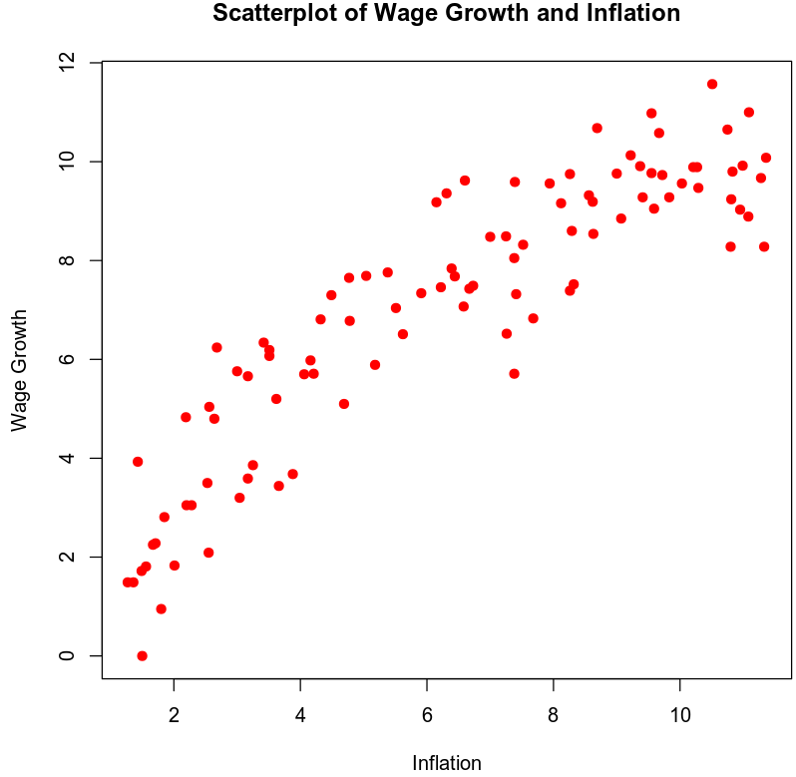

*A second order model is appropriate in this case because our predictor variable can have a non-linear relationship with our response variable. Our predictor variable here can have a trend that increases or decreases based on other factors, and is not only dependant on our response variable.*

### Reporting Results

*The general equation for the second order regression model for wage growth using inflation as the predictor variable is:*

$$E\left(Y\right)=β_{0}+β_{1}X+β_{2}X^{2}$$

$β_{0}$*is our intercept. $β_{1}$ is our popular regression term for inflation and our $β_{2}$ is our popular regression term for inflation2 (inflation squared). Our X and X2 terms are the values of inflation and inflation2 that we can substitute hypothetical terms for.*

*Our model equation is:*

$$\hat{Y}=-0.39508+1.81077\left(X\right)-0.08129\left(X^{2}\right)$$

*The value of R2 (R-squared) is $0.8614$ and the value of $R_{a}^{2}$ (adjusted R-squared) is . The R2 value is the coefficient of multiple determination and tells us that approximately 86% of the variance in wage growth can be explained using a model that uses inflation as a predictor.*

*Our beta estimate for the term inflation is 1.81044 and our beta estimate for inflation2 is -0.08129. The coefficient for inflation does not have a meaning interpretation when a squared term is present in the model. The coefficient for inflation2 is negative, therefore it indicates a curved relationship with downward concavity.*

### Evaluating Model Significance

*The null and alternative hypotheses for an overall F-test are:*

$$H_{0} :β_{1}=β_{2}=0$$

$$H_{a} :at least one β_{i}≠0 for i=1, 2$$

*The P-value of our overall F-test is $2.2e-16$ which is significantly lower than our 5% level of significance. As such, we should reject our null hypothesis in favor of our alternative hypothesis. With this we can conclude that a statistically significant relationship exists between wage growth and inflation.*

*To see which terms are significant in the model, we use an individual T-test for each variable. The null and alternative hypotheses for this are:*

$$H_{0} :β_{i}=0 for some i=1, 2, …, n$$

$$H_{a} :β_{i}≠0$$

*The P-value for inflation is $2e-16$ and the P-value for inflation2 is . They are both well below our 5% level of significance. With these P-values, we can conclude that both variables, individually, are statistically significant at a 5% level of significance.*

### Making Predictions Using Model

*To make predictions using the regression model, we will use a hypothetical value of inflation = 7.41, and use this to predict wage growth. For our scenario we will use out equation for the second order regression model:*

$$E\left(Y\right)=β_{0}+β_{1}X+β_{2}X^{2}$$

$$\hat{Y}=-0.39508+1.81077\left(7.41\right)-0.08129\left({7.41}^{2}\right)$$

$$\hat{Y}=-0.39508+13.4178057-4.463479$$

$$\hat{Y}=8.5592467$$

*Our predicted wage growth if inflation is 7.41 is $8.5592$.*

*The 95% prediction interval for the wage growth is $(6.4568, 10.6616)$. This tells us that, taking regression error into account; we can be 95% certain that an individual data point for wage growth will fall within these bounds, if inflation is 7.41.*

*The 95% confidence interval for the wage growth is $(8.2473, 8.871)$. This tells us that the average of a group of data points for wage growth will fall within these bounds, if inflation is 7.41.*

## **4. Complete Second Order Model with Two Quantitative Variables**

### Reporting Results

*The general equation for the second order regression model with wage growth as the response variable, and inflation and GDP growth as predictor variables is:*

$$E\left(Y\right)=β_{0}+β_{1}X_{1}+β_{2}X_{2}+β_{3}X_{1}X_{2}+β_{4}X_{1}^{2}+β_{5}X_{2}^{2}$$

*Our $β_{0}$ is our intercept. $β_{1}$ is our popular regression parameter for inflation, $β_{2}$ is our popular regression parameter for GDP growth, $β_{3}$ is our popular regression parameter for the interaction between inflation and GDP growth, $β_{4}$ is our popular regression parameter for inflation2, and is our popular regression parameter for GDP growth2. Our terms are the value for inflation and the value for GDP growth. Our $X_{1}^{2} \& X_{2}^{2}$ terms are the values for inflation2 and GDP growth2.*

*Our equation for this would be:*

$$\hat{Y}=-0.39508+1.060687X_{1}+0.545357X_{2}-0.034358X_{1}X_{2}-0.027371X_{1}^{2}-0.003176X_{2}^{2}$$

*The value of R2 (R-squared) is 0.9113 and the value of $R_{a}^{2}$ (adjusted R-squared) is 0.9065. Our R2 value of 0.9113 is our coefficient of determination, we can conclude that approximately 91% of the variation in wage growth can be explained by the model using predictors for inflation and GDP growth.*

*The beta estimate for Inflation is 1.060687. The beta estimate for GDP is 0.545357. The beta estimate for the interaction of Inflation against GDP is -0.034358. The beta estimate for GDP2 (GDP squared) is -0.003176 and the beta estimate for inflation2 is . The coefficient for inflation nor GDP have a meaning interpretation when a squared term is present in the model. Both the coefficient for inflation2 and GDP2 are negative, therefore they each have a relationship with downward concavity.*

### Evaluating Model Significance

*To evaluate model significance for the regression model, we carry out an overall F-test. Our null and alternative hypotheses for this are:*

$$H_{0} : β_{1}=β_{2}=⋯=β_{n}=0$$

$$H_{a} :at least one β_{i}≠0 for i=1, 2, …, n$$

*The P-value for this model is 2.2e-16. This is vastly lower than our 5% level of significance. This tells us we should reject our null hypothesis, in favor of our alternative hypothesis. As such, we can conclude that there is a statistically significant relationship between our response variable and at least one of our predictor variables.*

*To see which predictor variables (inflation, GDP) have a statistically significant relationship with our response variables (wage growth), we perform an individual T-test. Our null and alternative hypothesis for this is:*

$$H_{0} :β_{i}=0 for some i=1, 2, …, n$$

$$H_{a} :β_{i}≠0$$

*The P-value for inflation is 4.68e-07. The P-value for GDP is 3.42e-06. The P-values for inflation2 is 0.1706. The P-value for GDP2 is 0.5837. The P-value for the interaction term of inflation against GDP is 0.0563.*

*At a 5% level of significance, inflation and GDP are statistically significant. This is concluded due to the fact that the P-value for these terms is far lower than our level of significance.*

### Making Predictions Using Model

*Our equation to predict wage growth if inflation is 7.41 and GDP growth is 9.59 is:*

$$\hat{Y}=-0.39508+1.060687\left(7.41\right)+0.545357\left(9.59\right)$$

$$-0.034358(7.41*9.59)-0.027371({7.41}^{2})-0.003176({9.59}^{2})$$

$$\hat{Y}=8.4579$$

*The 95% prediction interval for wage growth is (6.744, 10.1718). This tells us that, taking regression error into account; we can be 95% certain that an individual data point for wage growth will fall within these bounds, if inflation is 7.41 and GDP growth is 9.59.*

*The 95% confidence interval for wage growth is (8.1751, 8.7407). This tells us that we can be 95% certain that the average of a group of data points for wage growth will fall within these bounds, if inflation is 7.41 and GDP growth is 9.59.*

## **5. Complete Second Order Model with One Quantitative and One Qualitative Variable**

### Reporting Results

*The general form equation for a complete second order regression model for wage growth, using inflation and economy as predictor variables is:*

$$E\left(Y\right)=β_{0}+β_{1}X_{1}+β_{2}X_{2}+β_{3}X_{1}X_{2}+β_{4}X_{1}^{2}+β_{5}X_{1}^{2}X_{2}$$

*Our $β_{0}$ is our intercept. $β_{1}$ is our popular regression parameter for inflation, $β_{2}$ is our popular regression parameter for economy, $β_{3}$ is our popular regression parameter for the interaction between inflation and economy, $β_{4}$ is our popular regression parameter for inflation2, and is our popular regression parameter for the interaction term of economy against inflation2. Our terms are the value for inflation and the dummy value for economy. Our $X_{1}^{2}$ term is the value for inflation2.*

*Our equation for this second order regression model, with wage growth as the response variable and inflation and economy as predictors is:*

$$\hat{Y}=1.38806+1.33488X_{1}-3.48576X_{2}+1.41440X_{1}X_{2}-0.05175X_{1}^{2}-0.16300X_{1}^{2}X_{2}$$

*The value of R2 (R-squared) is 0.8738 and the value of $R_{a}^{2}$ (adjusted R-squared) is* *0.867. Our R2 value of 0.8728 is our coefficient of determination, we can conclude that approximately 87% of the variation in wage growth can be explained by the model using predictors for inflation and economy.*

### Evaluating Model Significance

*To evaluate if the model is significant at a 5% level of significance, we will carry out an overall F-test. Our null and alternative hypotheses are:*

$$H_{0} : β_{1}=β_{2}=⋯=β_{n}=0$$

$$H_{a} :at least one β_{i}≠0 for i=1, 2, …, n$$

*Our P-value for this model is 2.2e-16. This is far below our level of significance of 0.05. As such, we should reject our null hypothesis, in favor of our alternative hypothesis. With this, we can conclude that at least one of our predictor variables (inflation and economy), has a statistically significant relationship with our response variable (wage growth).*

*To evaluate which terms are significant in the model, we will perform individual T-tests on each of our predictor variables and use a 5% level of significance. Out P-Value for inflation is 5.45e-08, our P-value for economy is 0.10773, our P-value for the interaction of inflation against economy is 0.39118, our P-value for inflation2 is 0.00167, and our P-value for the interaction of economy against inflation2 is 0.59197.*

*With this information, we can conclude that the terms that are statistically significant at a 5% level of significance are inflation and inflation2.*

### Making Predictions Using Model

*Using our model, we can predict wage growth. In our scenario inflation is 7.41 and the economy is not in recession. For this equation our dummy variables for no recession is ‘0’ for recession is ‘1’.Our equation for this prediction is:*

$$\hat{Y}=1.38806+1.33488\left(7.41\right)-3.48576\left(0\right)+1.41440\left(7.41*0\right)$$

$$-0.05175(54.9081)-0.16300(54.9081*0)$$

$$\hat{Y}=8.4379$$

*So the predicted wage growth if inflation is 7.41 and the economy is not in recession is 8.4379.*

*The 95% prediction interval for wage growth for this model is (6.3961, 10.4796). This tells us that, taking regression error into account; we can be 95% certain that an individual data point for wage growth will fall within these bounds, if inflation is 7.41 and the economy is not in recession.*

*The 95% confidence interval for wage growth for this model is (8.1175, 8.7582). This tells us that the average of a group of data points for wage growth will fall within these bounds, if inflation is 7.41 and the economy is not in recession.*

*The prediction interval is wider than the confidence interval because the prediction interval not only takes sampling uncertainty into account, it also takes into account uncertainty related to $Y$  varying according to the regression error, $ϵ$ .*

## **6. Conclusion**

*Based on the analysis that was performed and assuming the sample size is sufficiently late, I would recommend this model. It shows that most of the variables we tested in our 3 regression models have a statistically significant relationship with wage growth.*

*The results of the analyses done using the three models, shows us that there is a strong correlation between our predictor variables and wage growth as our response variable. We can conclude that 86% of the variance in wage growth can be explained using a model with inflation as a predictor. We are able to conclude that 87% of our variance in wage growth can be explained using a model that adds economy as a variable, along with inflation. If we look at inflation and GDP growth as our predictors, we can conclude that 91% of our variance in wage growth can be explained with this model.*

*The practical importance of the analyses that were performed is that it can be used by economists to predict wage growth. They can evaluate how different variables have an effect on wage growth, and use the variables that are statistically significant to more accurately predict wage growth.*

## **7. Citations**

*Zybooks MAT 303: Applied Statistics II for Science, (2016, August).*

*Retrieved March 16, 2020, from https://learn.zybooks.com/zybook/SNHUMAT303v1*